Personalized Safety Plan

The following steps represent my plan to try to increase my safety and prepare for the possibility of future abuse or violence. Although I do not have control over my partner’s actions, I do have options about how to respond to those actions based on my experiences and what I now about my partner.

STEP 1: Safety during a violent incident
People cannot always avoid abusive incidents. In order to increase safety, persons who are experiencing abuse and/or violence in a relationship may use a variety of strategies.

I can use some or all of the following strategies:
- If I decide to leave, I will ______________________________________________. (Practice how to get out safely. What doors, windows, elevators, stairwells or fire escapes would you use?)

- I can keep my wallet and car keys ready and put them (place) _________________ _____________________________ in order to leave quickly.

- I can tell _______________________________________________ about the violence and ask them to call for help if they hear suspicious noises coming from my house.

I can also tell ___________________________________________ about the violence and ask them to call the police if they hear suspicious noises coming from my house.

- I can teach my children how to use the phone to contact help.

- I will use __________________________ as my code word with my children and/or my friends so they will know to call for help.

- If I have to leave the house, I will go _____________________________________. (Decide this even if you don’t think there will be a next time.)

If I cannot go to the location above, then I can go to _________________________ or __________________________________________.

- I can also teach some of these strategies to some/all of my children.

- When I expect we are going to have an argument, I will try to move to a space that is lowest risk, such as ________________________________________________. (Try to avoid arguments in the bathroom, garage, kitchens, near weapons, or in rooms without access to an outside door.)

- I will use my judgment and intuition. If the situation calls for it, I can give my partner what they want to calm them down. I have to protect myself until my children and I are out of danger.

STEP 2: Safety in my own residence
There are many things that a person can do to increase her safety in her own residence. It may be impossible to do everything at once, but safety measures can be added step by step.

Safety measures I can use include:
- I can change the locks on my doors and windows as soon as possible.
- I can replace wooden doors with steel/metal doors.
- I can install security systems, including additional locks, window bars, poles to wedge against doors, an electronic system, etc.
- I can purchase rope ladders to be used for escape from second floor windows.
- I can install smoke detectors and purchase fire extinguishers for each floor of my house or apartment.
- I can install an outside lighting system that lights up when a person is coming close to my house.
- I will teach my children how to use the phone to make a collect call to me and to _________________________________________ (friend, faith leader, other) in the event that my partner takes my children.

- I will tell people who take care of my children which people have permission to pick up my children and that my partner is not permitted to do so. The people I will inform about the pick-up permission include:
_____________________________________________________ (school)
_____________________________________________________ (day care staff)
_____________________________________________________ (babysitter)
______________________________________________ (Sunday School teacher)
_____________________________________________________ (teacher)
_____________________________________________________ and
_____________________________________________________ (others)

- I can inform _______________________________________________ (neighbor)
_____________________________________ (minister, rabbi, or other faith leader)
and _________________________________________________________ (friend)
that my partner no longer resides with me and they should call for help if my partner is observed near my residence.

STEP 3: Sexual Safety Planning
Sexual assault is any kind of sexual conduct that you don’t consent to, regardless of your relationship. Your partner may make you feel like it is your ‘duty’ to have sex because of your relationship, or make you feel bad about sex and sexuality in other ways. Your partner may also control what happens in the bedroom in a way that makes you feel unsafe or at risk of contracting sexually transmitted infections, STIs (HIV, Chlamydia, Gonorrhea, Syphilis, Herpes, HPV).

- Do you know or suspect that your partner is having sex with other people?

- Do you feel you may be at risk for HIV or other STIs?

- Have you ever tested positive for or received treatment for any STIs?

- Have you noticed anything different about your body that is causing you concern?

STEP 4: Safety when preparing to leave
People who are managing abuse/violence in a relationship sometimes leave the residence they share with the partner. Leaving must be done with a careful plan in order to increase safety. Partners often strike back when they believe their partner is leaving the relationship.

I can use some or all of the following safety strategies:

- I will leave money and an extra set of keys with ____________________________ so I can leave quickly.

- I will keep copies of important documents (see step 8) or keys at _______________ _____________________________.

- I will open a savings account by _____________________________ to increase my independence.

- Other things I can do to increase my opportunities to make my own decisions include:
__________________________________________________________________
__________________________________________________________________
__________________________________________________________________

- The Domestic Violence Program’s Hotline number is ______________________. I can seek shelter by calling this hotline. (You can call the Virginia Family Violence & Sexual Assault Hotline at 1.800.838.8238 v/tty to get the number of your local Domestic Violence Program).

- I can keep my cell phone on me at all times. I understand that if I use my cell phone and my partner gets a hold of the phone or sees the bill, they may have access to the numbers that I have called.

- I will check with __________________________and ________________________ to see who would be able to let me stay with them and lend me some money.

- I can leave extra clothes with __________________________________________.

I will sit down and revise my safety plan every ______________________ in order to plan the safest way to leave my residence. ______________________ (domestic violence advocate or friend) has agreed to help me review this plan.

- I will rehearse my escape plan and, as appropriate, practice it with my children.

STEP 5: Safety with a Protective Order
Many respondents of protective orders follow the order, but one can never be sure who will obey and who will violate protective orders. I recognize that I may need to ask the police and the courts to help enforce my protective order.

The following are steps that I can take to help the enforcement of my protective order:
- I will keep my protective order __________________________________(location). (Always keep it on or near your person. If you change bags, that’s the first thing that should go in it.)

- I will give copies of my protective order to police departments in the community where I work, in those communities where I usually visit family or friends, and in the community where I live.

- I can call the local Domestic Violence Program if I have problems with or questions about my protective order.

- I will inform my employer, my minister/rabbi/faith leader, my closest friend, ___________________and ___________________ that I have a protective order in effect.

- If my partner destroys my protective order, I can get another copy from the clerk of the court.

- If my partner violates the protective order, I can call the police or go the magistrate and report the violation.

- If the police do not help, I can contact my domestic violence advocate, my attorney and/or the Commonwealth’s Attorney, and I can file a complaint with the chief of the police department or the sheriff.

- I can also file a Show Cause Petition with the clerk of the court in the jurisdiction where the Protective Order was issued. If my partner commits a new crime, I can file a private criminal complaint with the magistrate in the jurisdiction where the crime was committed. I can call the Domestic Violence Program to help me.

STEP 6: Safety on the job and in public
Each person must decide if and when they will tell others that their partner has been abusive to them and that they may be at continued risk. Friends, family, and coworkers can help to create safety. Everyone should consider carefully which people to invite to help them feel more secure.

I might do any or all of the following:

- I can inform my boss, the security supervisor, and __________________________ at work of my situation.

- I can ask __________________________ to help screen my phone calls at work.

- When leaving work, I can ______________________________________________ __________________________________________________________________.

- When driving home if problems occur, I can _______________________________
__________________________________________________________________.

- If I ride the bus or metro, I can __________________________________________ __________________________________________________________________.

- I can use different grocery stores and shopping malls to get what I need and I can shop at hours that are different from those my partner might expect.

- I can use a different bank and take care of my banking at hours that are different from those I used when I was with my partner.

- I can also _________________________________________________________.

STEP 7: Safety and drug or alcohol use
Many people use alcohol. Many use mood-altering drugs. Much of this use is legal, and some is not. The legal outcomes of using illegal drugs can be very hard on a person, may hurt their relationship with their children, and put them at a disadvantage in other legal actions with their partner. Therefore, people should carefully consider the potential cost of the use of illegal drugs. Beyond this, the use of any alcohol or other drugs can reduce a person’s awareness and ability to act quickly to protect themselves from their partner. Furthermore, the use of alcohol or other drugs by the partner may give them an excuse to use violence. Therefore, in the context of drug or alcohol use, it’s important to consider specific safety plans.

If drug or alcohol use has occurred in my relationship with my partner, I can enhance my safety by some or all of the following:

- If I am going to use, I can do so in a safe place and with people who understand the risk of violence and are committed to my safety.

- I can also __________________________________________________________.

- If my partner is using, I can ____________________________________________.

- I might also_________________________________________________________.

- To safeguard my children, I might _______________________________________
__________________________________________________________________.

STEP 8: Safety and my emotional health
The experience of being battered and abused in other ways (verbally, sexually, financially, etc.) is exhausting and emotionally draining. The process of building a new life for myself takes much courage and incredible energy.

To conserve my emotional energy and resources, and to avoid hard emotional times, I can do some or all of the following:

- If I feel down and ready to return to a potentially abusive situation, I can __________________________________________________________________.

- When I have to communicate with my abuser in person or by phone, I can ____________________________________________________________________________________________________________________________________.

- I can try to use “I can…” statements with myself and to be assertive with others.

- I can tell myself “____________________________________________________” whenever I feel others are trying to control or abuse me.

- I can read ______________________________________ to help me feel stronger.
- I can call ___________________________, ______________________________, and/or __________________________ as other resources to support me.

- Other things I can do to help me feel stronger are __________________________, _________________________, and ____________________________________.

- I can attend workshops and support groups at the Domestic Violence Program or _________________________________ or ______________________________ or _______________________________ to gain support and strengthen my relationships with other people.

STEP 9: Items to take when leaving
If you leave your partner, it is important to take certain items with you. Some people also give an extra copy of papers and an extra set of clothing to a friend just in case they have to leave quickly.

When I leave, I should take the following items. These items might be best placed in one location, so that if we have to leave in a hurry, I can grab them quickly.

MOST IMPORTANT:
- Identification for myself
- Children’s birth certificates
- My birth certificate
- Social Security cards
- School and vaccination records
- Money
- Checkbook, ATM or debit card
- Credit cards
- Keys – house, car, office, etc.
- Driver’s license and registration
- Medications

OTHER ITEMS YOU MAY WANT:

- Welfare identification
- Work permits
- Green card
- Passport(s)
- Divorce papers
- Medical records
- Lease/rental agreement, house deed, and/or mortgage payment book
- Bank books
- Insurance papers
- Small, salable objects
- Address book
- Pictures
- Jewelry
- Children’s favorite toys and/or blankets
- Items of special sentimental value

Important Phone Numbers

Domestic Violence Program: ____________________________________________
Police department (home): _____________________________________________
Police department (school): _____________________________________________
Police department (work): ______________________________________________
Work number: _______________________________________________________
Supervisor’s home number: _____________________________________________
Minister, rabbi, or other faith leader: _______________________________________
Other: ____________________________________________________________
____________________________________________________________
____________________________________________________________

For more information, I can contact:
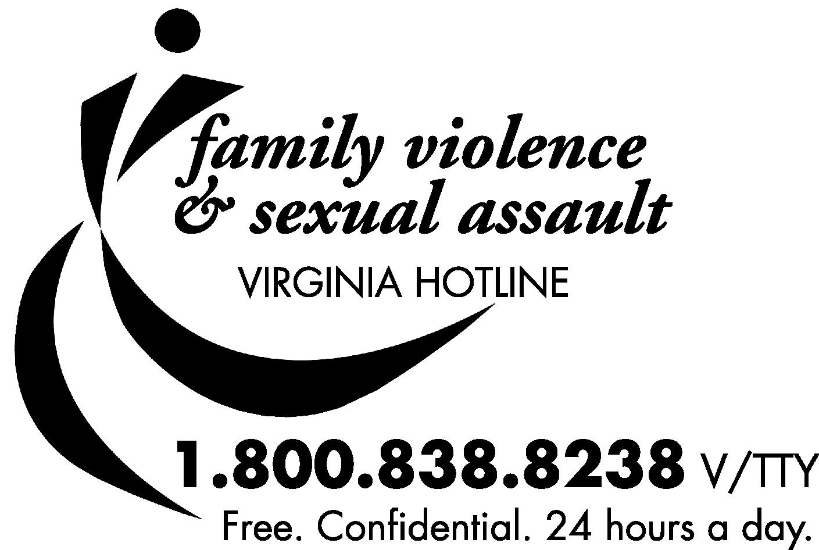

Adapted from: Personalized Safety Plan, Office of the City Attorney, San Diego, California, April 1990.

